Books for 2022/23

See Mosaic website: https://www.mosaicbooks.ca/schools-teachers

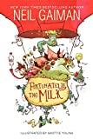
Books Grade 3/4
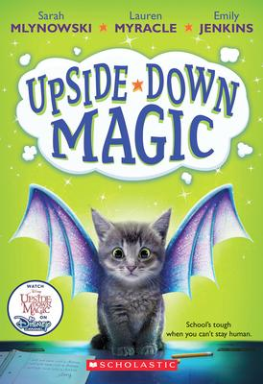 |  | 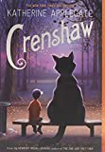 |  |  | 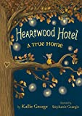

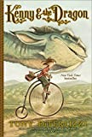 | 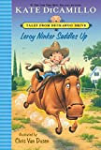 |  | 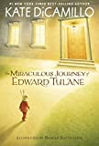 | 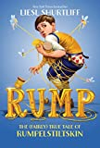 | 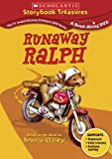

Upside-Down Magic
Crenshaw
Fortunately, the Milk
Heartwood Hotel

Kenny and the Dragon
Leroy Ninker Saddles Up: Tales from Dekawoo Drive
The Miraculous Journey of Edward Tulane
Rump: The True Story of Rumplestiltskin
Runaway Ralph

Grade 5 Books
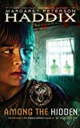 | 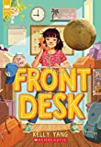 | 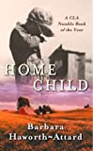 | 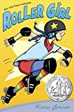

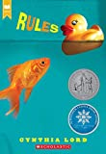 | 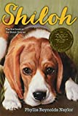 | 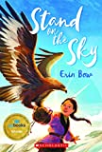 | 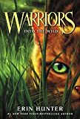 | 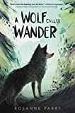

Among the Hidden
Front Desk
Home Child
Stand on the Sky
Roller Girl (Graphic Novel)
Rules
Shiloh
Warriors: Into the Wild
A Wolf Called Wander

Grade 6 Books
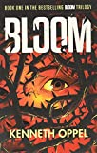 | 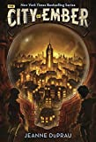 | 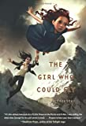 | 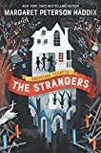 | 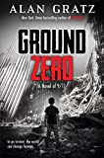 | 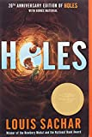

 | 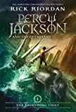 | 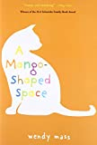 |  |  |  | 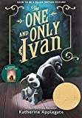
Bloom
The City of Ember
The Girl Who Could Fly
Greystone Secrets: The Strangers
Ground Zero
The Lightning Thief: Percy Jackson and the
Olympians, Book 1
A Mango-Shaped Space
The One and Only Ivan
Holes

