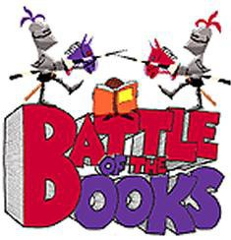  Battle of the Books 2022/23  Grade 3  _____ Fortunately, The Milk  by Gaiman, Neil  ____ Heartwood Hotel:  A True Home  by George, Kallie  ____ Kenny & the Dragon  by Diterlizzi, Tony  ____ Leroy Ninker Saddles Up  by DiCamillo, Kate  _____ Runaway Ralph  by Cleary, Beverly | Battle of the Books 2022/23  Grade 3  _____ Fortunately, The Milk  by Gaiman, Neil  ____ Heartwood Hotel:  A True Home  by George, Kallie  ____ Kenny & the Dragon  by Diterlizzi, Tony  ____ Leroy Ninker Saddles Up  by DiCamillo, Kate  _____ Runaway Ralph  by Cleary, Beverly | Battle of the Books 2022/23  Grade 3  _____ Fortunately, The Milk  by Gaiman, Neil  ____ Heartwood Hotel:  A True Home  by George, Kallie  ____ Kenny & the Dragon  by Diterlizzi, Tony  ____ Leroy Ninker Saddles Up  by DiCamillo, Kate  _____ Runaway Ralph  by Cleary, Beverly

